

**Adama Science and Technology University**

**School of Electrical Engineering and Computing**

**Course Title:** Fundamentals of Electrical Engineering

**Course Number:** PCE2101

**Lab:** Laboratory Experiment No - 4

**Title:** Maximum Power Transfer

**Prepared by:**

**Name ID No.**

1. Daniel Adisu R/0331/08
2. Debebe Asefa R/0368/08
3. Dejene Tesfaye R/0375/08
4. Duguma Yeshitla R/0394/08
5. Edget Negussie R/0399/08
6. Dawit Elias R/0348/08
7. Daniel Balo R/0335/08
8. Dawit Demelash R/0347/08
9. Destaw Fikadie R/0388/08
10. Desale GebreMicail R/0383/08

**Submitted to:** Lecturer Tewdros

Date of conduction: December 30, 2016

Date of submission: January 5, 2016

**Acknowledgement**

We would like to acknowledge our lab assistant Tewdros for his support and explanation in the laboratory. Through the group work and experiment we were able to comprehend the topics that were raised and able to communicate with each other well.

**Theoretical Background**

In many practical situations, a circuit is designed to provide power to a load. There are applications in areas such as communications where it is desirable to maximize the power delivered to a load.

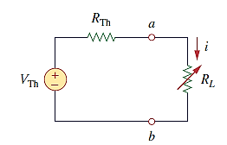

***Figure: A Thevenin Resistor with variable load***

Maximum power is transferred to the load when the load resistance equals the Thevenin resistance as seen from the load (*RL =* *R*Th).

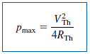

**Lab – 4: Maximum Power Transfer**

**Objectives:**

* To verify Maximum Power Transfer theorem

**Apparatus Used:**

* Fixed and variable Resistors of different values
* DC power supply

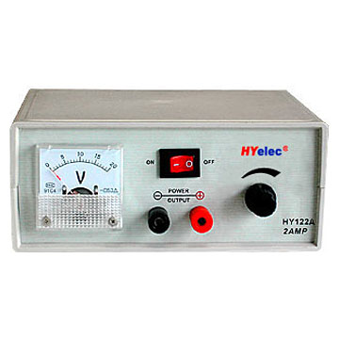

* Connectors
* Digital Multimeter (DMM)



**Procedures**

1. At the beginning of our experiment we placed our instruments and apparatus carefully on our working space.
2. Thereafter we constructed the circuit, as instructed by our experiment procedure, shown in figure 1.

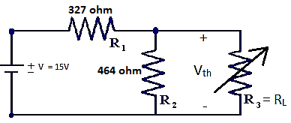

***Figure 1: Experimental Circuit***

1. Then we determined the Thevenin resistance by taking R1 and R2 in parallel.

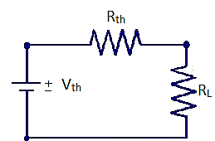

***Figure 2: Thevenin Equivalent circuit***

1. And following the above we measured and recorded the power dissipated by the load resistor at various resistances.
2. Finally we plotted a graph of power versus load resistance.

**Result and Discussion**

From the experiments we have done, we have obtained the following measurements.

* RTh = 192 $Ω$

|  |  |  |  |  |  |  |  |  |
| --- | --- | --- | --- | --- | --- | --- | --- | --- |
| R ($Ω$) | 50 | 100 | 150 | 192 | 250 | 300 | 350 | 400 |
| VL (V) | 2.42 | 4.1 | 5.25 | 6.01 | 6.76 | 7.34 | 7.76 | 8.1 |
| Power | 0.117 | 0.168 | 0.184 | 0.188 | 0.187 | 0.179 | 0.172 | 0.164 |

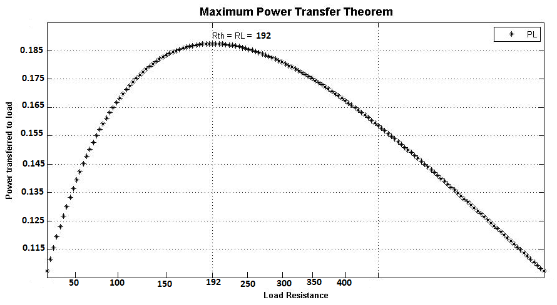

***Figure 3: Power versus Load resistance graph***

**Conclusion**

We have observed the following points about the Maximum Power Transfer:

* The maximum power is dissipated when the varied load resistor is equal to the Thevenin resistor which is connected in series with it.
* The powers before and after the when the load resistor is equal to Thevenin resistor are lesser than the maximum power.
* So to get a maximum power across the load, we have to set the load resistance equal to Thevenin resistance.

**References**

* Fundamentals of Electric Circuits, C. K. Alexander and M. N. O. Sadiku

**Thank you!!!**